

**Garage-Master**

1. **Project Overview**

This project is focused on developing a Garage Management System designed to streamline the day-to-day operations of an automotive repair shop. The goal is to create an efficient, user-friendly system using Salesforce to manage appointments, inventory, customer data, billing, and vehicle services. This project will enhance operational efficiency, improve customer experience, and support long-term growth for the garage by utilizing cloud-based CRM tools.

1. **Objectives**

List the specific, measurable goals the project intends to achieve. Examples:

**Business Goals:**

* + Improve appointment scheduling efficiency and reduce customer wait times.
  + Enhance inventory accuracy to prevent stock-outs and over-ordering.
  + Provide clear, data-driven insights into garage performance and customer satisfaction.

**Specific Outcomes:**

* + A custom solution for managing vehicle service records, inventory, and billing.
  + Automated workflows for updating inventory and notifying customers.
  + Interactive dashboards to track garage performance metrics.

1. **Salesforce Key Features and Concepts Utilized**
   * **Custom Objects and Fields:** To manage data for vehicles, customers, service details, and inventory.
   * **Role-Based Access Control:** Ensures only authorized users can access sensitive data.
   * **Automation Tools:** Salesforce Flows and Process Builder automate appointment reminders and inventory management.
   * **Reports & Dashboards:** Provide insights into garage activities, such as parts usage and revenue.





**4.Detailed Steps to Solution Design**

* + **Data Model:** Define entities like Customer, Vehicle, Service Record, and Inventory Item.
  + **User Interface:** Create custom page layouts for service scheduling and customer check-ins.
  + **Business Logic:** Set up Process Builder and Flow to automate notifications and inventory updates.
  + **Screenshots:** Include relevant screenshots of custom objects, fields, and automation workflows to illustrate each design element.

**APP LAUNCHER :**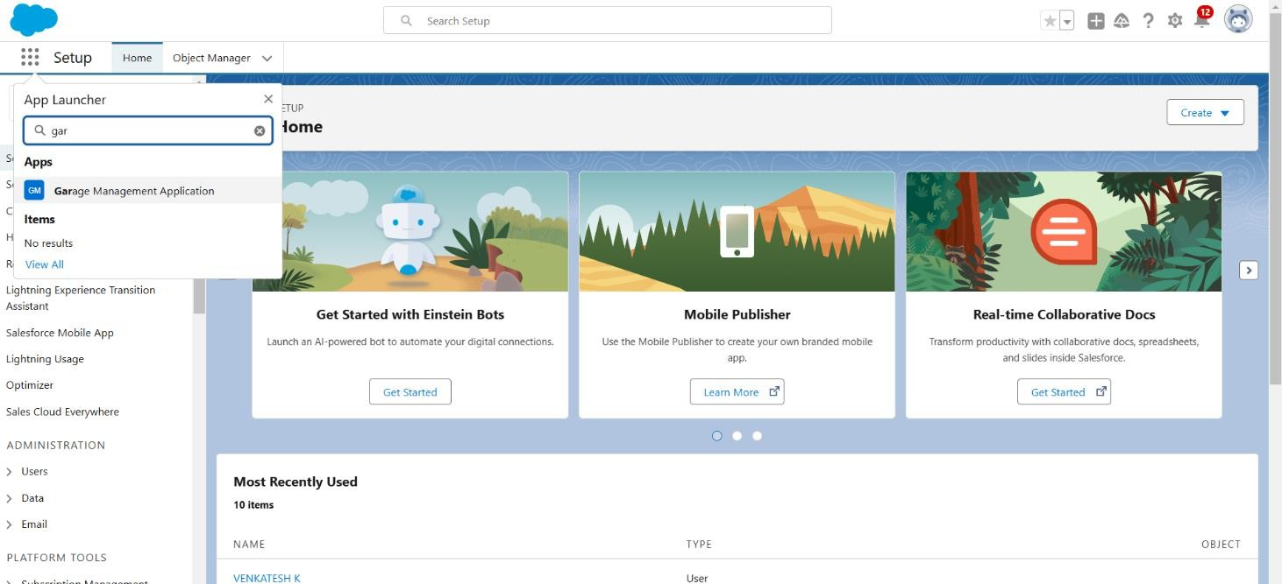

**GARAGE MANAGEMENT SYSTEM :**

1. **Customer Details**

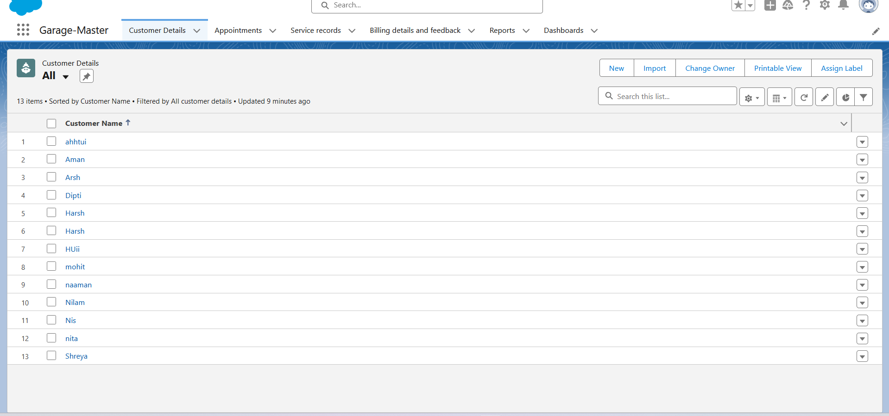

**2.Appointments**

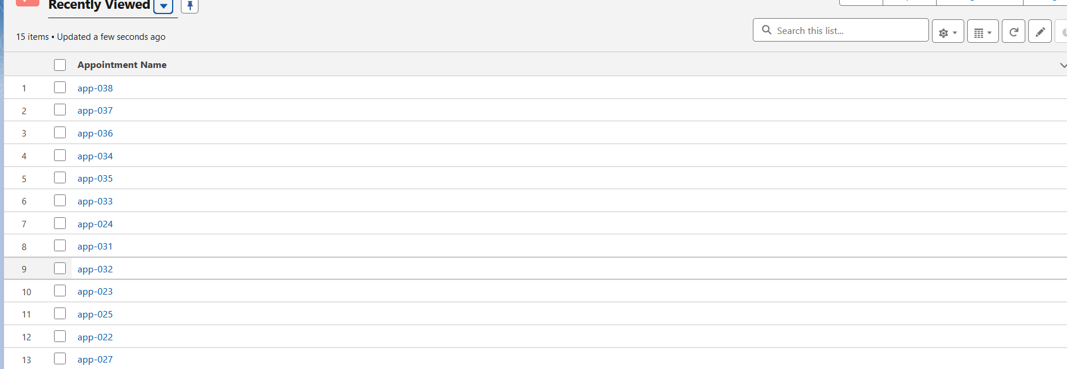

**3. Service Record**

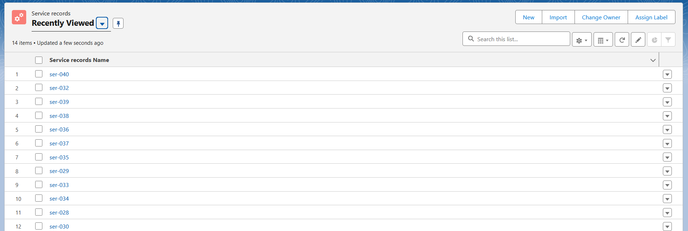

**4. Billing details and feedback Object**

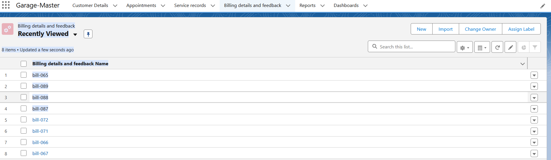

**5. Reports**

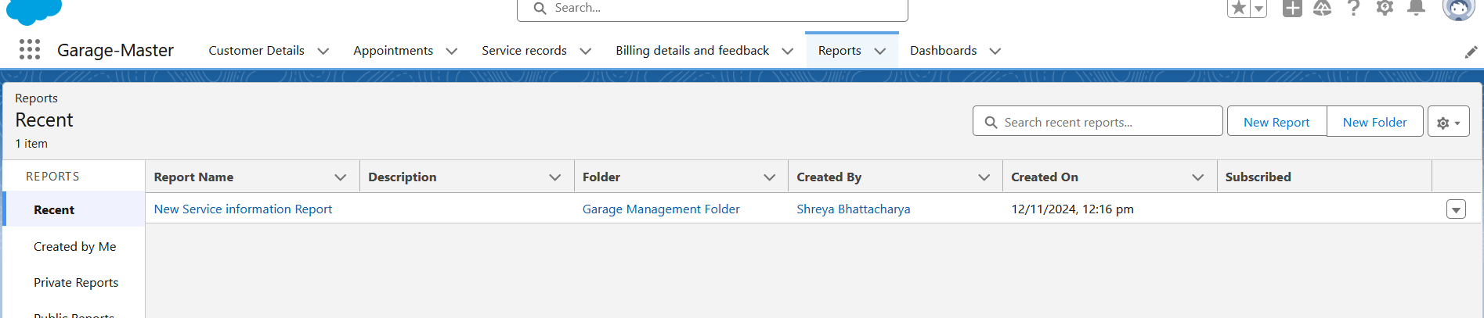

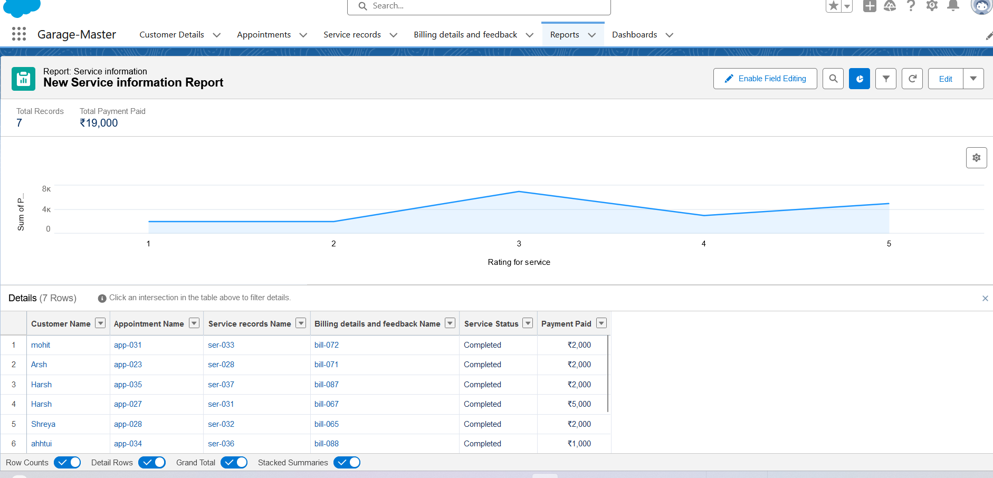

**6. Dashboards**

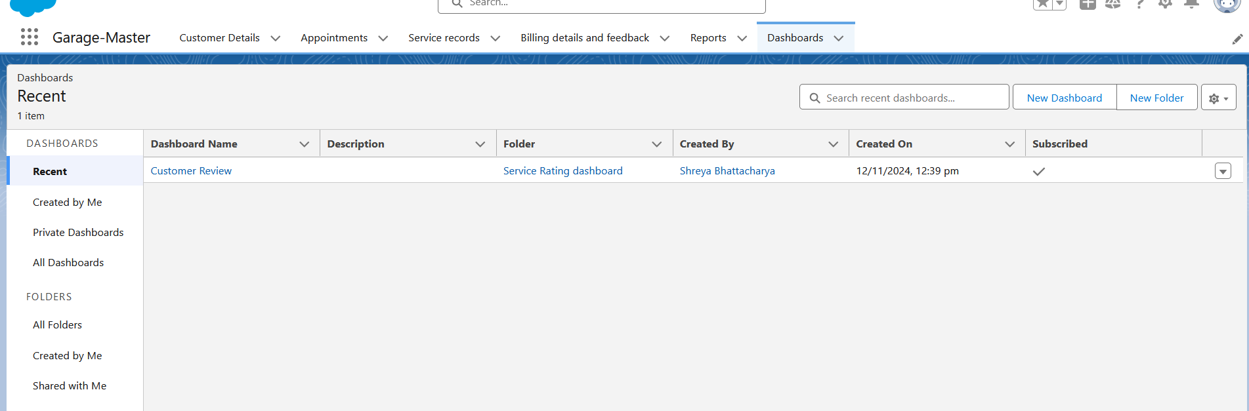

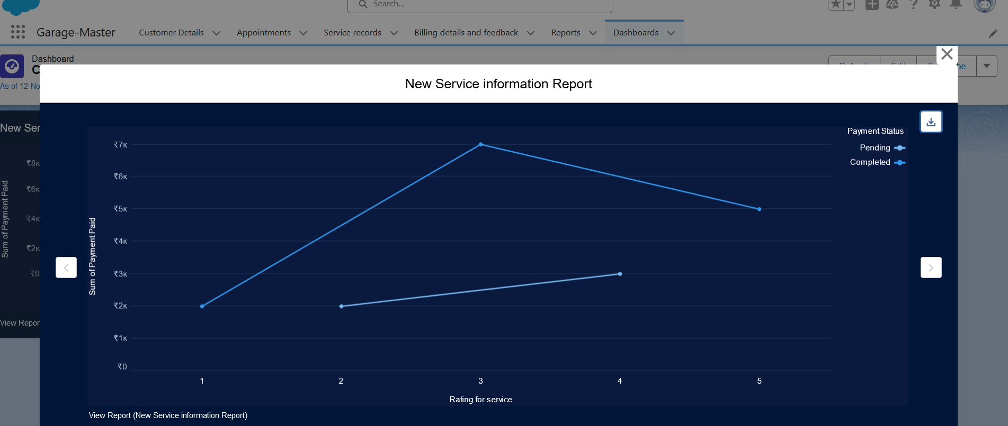

**5.Testing and Validation**

* + **Unit Testing:** Test Apex classes and triggers to ensure business logic works as intended.
  + **User Interface Testing:** Validate that all user roles have access to appropriate fields and functionality.

**6.Key Scenarios Addressed by Salesforce**

* + **Appointment Management**: Enables easy scheduling, reminders, and rescheduling for customers.
  + **Inventory Control**: Automates parts tracking and reordering.
  + **Billing and Invoicing**: Simplifies invoicing and keeps financial records up-to-date.

**7.Conclusion**

**Summary of Achievements:**

The **Garage-Master** project successfully delivered a customized solution that manages all core garage operations in a single platform. The system’s automation and data tracking capabilities have greatly improved workflow efficiency and customer satisfaction, supporting scalable growth for the garage.